
AMC Connect
1st Page. Home: Opening the site.
Change the colours.

Remove option Blog and replace courses with our services
Dark mode (optional)
Fixed button, redirect to contact form
Start your journey today!

You Are Not Alone in Your University Journey
We are here to guide you with patience, answer your questions clearly, and support you at a pace that feels right for you.

Free Support, Personalised Guidance
All our assistance is free for students. We work through official partnerships with universities, which allows us to offer support without fees or hidden charges.
You deserve guidance that feels honest and safe when making decisions about your future. We are here to provide that support with integrity and care.


Help Me Understand My Options – questionnaire
Always on screen
We are to help you take the next step with clarity.
✔️ University enrolment
✔️ CV & Personal Statement assistance
✔️ Easy document upload
✔️ Exam preparation support
✔️ Help with student finance applications
✔️ Guidance throughout your studies

FREE!

Floating button, redirect to questionaire
Fixed button, redirect to contact form
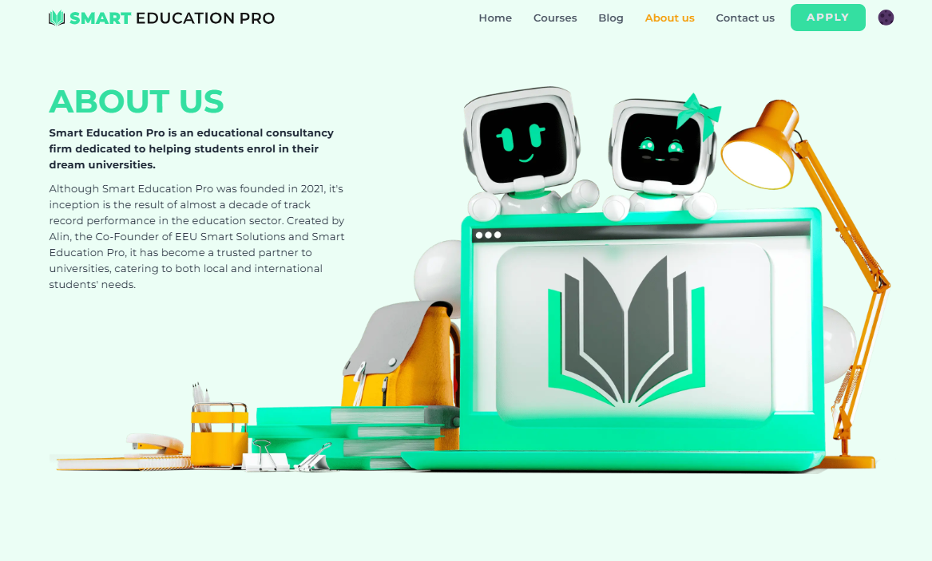
AMC Connect

Who We Are
AMC Connect was created with a simple purpose: to support students in a way that feels honest, patient, and personal.
We have spent years helping students enrol in universities across the United Kingdom. Through this experience, we have learned that what students need most is clarity, trust, and people who genuinely care about their goals.
Team pictures

Why We Do This
We believe that education can open doors and shape lives, but it should begin with informed and confident decisions. Our work is guided by honesty, respect for individual circumstances, and long-term support.
Most of the students who come to us are referred by someone we previously helped. This trust matters more to us than statistics or growth targets.

How We Help
We provide guidance with university applications, personal statements, documents, exam preparation, and Student Finance. Our support does not end at enrolment. We remain available during your studies whenever you need help or advice.
We want you to feel secure, prepared, and confident at every stage of your journey. No pressure. No rushing. Just support that respects your goals and your pace.
If you have questions or would like to discuss your options, we are always open to a conversation.

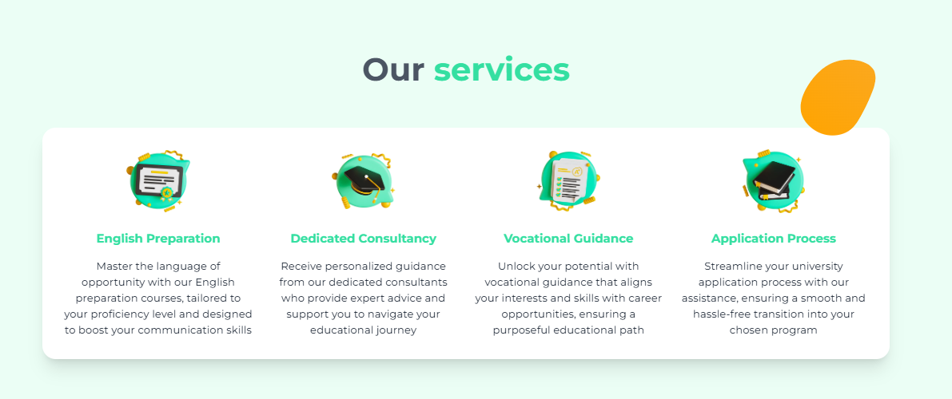
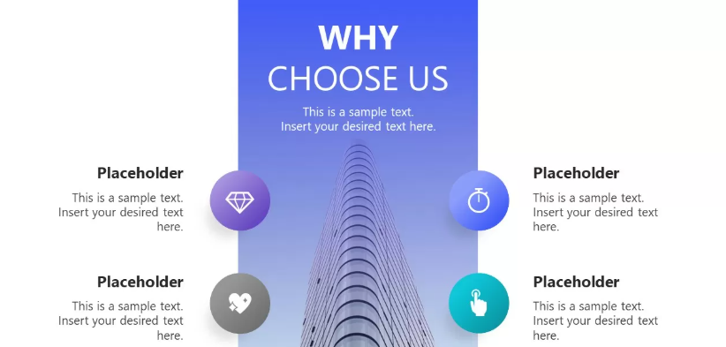
Application Support
Benefit from professional assistance in preparing your university application, CV, personal statement, and document submissions to ensure your application stands out.
Personalised University Guidance
We provide expert advice to help you select the university and course that best aligns with your academic and career ambitions.
Courses:
Undergraduate, postgraduate courses, HND/ Top – up
all UK locations

Comprehensive Services: End-to-end assistance from application to interview preparation and finance.
Why choose us? A DIFFERENT APPROACH TO SUPPORT
What You Can Expect From Us
• We listen before we advise
• We guide you step by step if you choose to enrol to University
• We make the application process clear and manageable
• We help you understand your financial options
• We support you during your studies, not only before enrolment
LOGO
Personalised Support: Tailored services to match your unique goals.
Availability: Reliable support whenever you need it.
Expertise: In-depth knowledge and experience in supporting students at every stage.

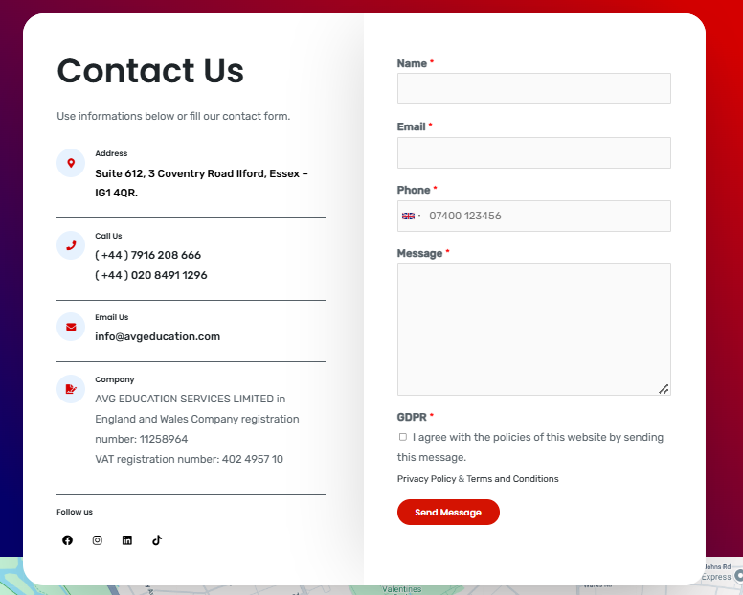
AMC Connect
Phone: UK 07955 528885
Mail: info@amc-connect.co.uk
Address: Unit 3, KD Tower, Cotterells, Hemel Hempstead, HP1 1FW.
Linkedin: https://www.linkedin.com/company/amc-connect-uk/?viewAsMember=true
Facebook: (will provide soon)
Company: AMC Connect LTD
Company number: 16252583
Working hours: Mon – Sat 10:00-18:00
Questionnaire form+
Your name
Your phone number
Your email
If you have any questions or need help, just reach out to us, and we will get back to you as soon as we can!

